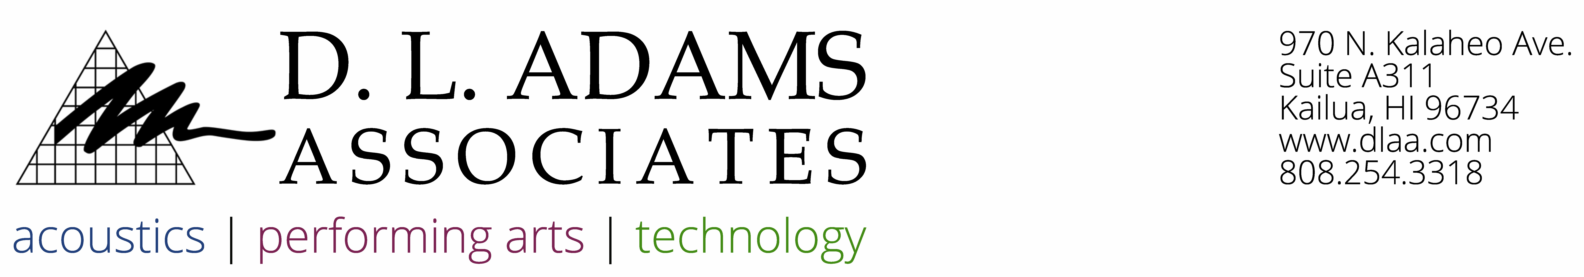November 11, 2022

Mr. Jeff Roberts

Ironwoods AOAO

1 Ironwoods Lane

Lahaina, HI 96761

**RE:** **Ironwoods Unit 73 ASTC and AIIC Mockup Testing Results – (DLAA No. 21-011)**

Dear Jeff:

DLAA conducted impact and airborne sound isolation tests between Ironwoods Unit 73 and Unit 71 in Lahaina, Maui, Hawaii on Thursday November 3, 2022. The floor/ceiling assembly tested was between the master bedroom areas of Unit 73 and Unit 71.

**Performance Criteria**

The Impact Insulation Class (IIC) is a single-number rating which grades how well a floor/ceiling assembly attenuates impact noise, such as footsteps. The higher the IIC rating, the more effective the partition is at reducing impact noise between spaces. It should be noted that the IIC rating is limited in that it does not address low frequency noise below 125 Hz. This is generally not a concern when with concrete and/or steel structures. Field measurements of impact noise are classified as Apparent Impact Insulation Class (AIIC). It is DLAA’s understanding that the Ironwoods AOAO has adopted a minimum design standard for floor/ceiling assemblies of IIC 55, which would correspond to a minimum field rating of AIIC 50.

Similarly, the Sound Transmission Class (STC) is a single-number rating which grades how well an assembly attenuates airborne noise, such as vocalizations. The higher the STC rating, the more effective the partition is at reducing airborne noise between spaces. Field measurements of airborne noise isolation are classified as Apparent Sound Transmission Class (ASTC). It is DLAA’s understanding that the Ironwoods AOAO has adopted a minimum design standard for floor/ceiling assemblies of STC 55, which would correspond to a minimum field rating of ASTC 50.

**Testing Procedure & Equipment**

Impact sound insulation was measured in general accordance with ASTM E1007-16, Standard Test Method for Field Measurement of Tapping Machine Impact Sound Transmission Through Floor-Ceiling Assemblies and Associated Support Structures. Impact sound insulation ratings are determined in accordance with ASTM E989-06 (2012), Standard Classification for Determination of Impact Insulation Class (IIC). The results include a single-number Apparent Impact Insulation Class (AIIC) rating.

Airborne sound insulation was measured in general accordance with ASTM E336-17a, Standard Test Method for Measurement of Airborne Sound Attenuation between Rooms in Buildings. Airborne sound insulation ratings are determined in accordance with ASTM E413, Standard Classification for Rating Sound Insulation (STC). The results include a single-number Apparent Impact Insulation Class (ASTC) rating.

Equipment used for testing included a Larson Davis Model 831 Type 1 Precision Integrating Sound Level Meter (S/N 002499) with a PCB Model PRM831 preamplifier (S/N 019073) and PCB Model 377B20 ½” random incidence microphone (S/N 124491). The sound level meter calibration was verified with a Larson Davis Model CAL200 (S/N 1283) before all measurements and at the conclusion of all measurements. The tapping machine is a Norsonic Model Nor-277 (S/N 2775671).

**Test Results Summary**

A summary of the tests is provided here, and the detailed test results for each test are attached.

**Table 1: AIIC and ASTC Test Results**

|  |  |  |
| --- | --- | --- |
| **Test No.** | **Adjacency Tested** | **Result** |
| 21-011D-AIIC | Unit 73 MBR and Unit 71 MBR | AIIC 61 |
| 21-011D-ASTC | Unit 73 MBR and Unit 71 MBR | ASTC 47 |

Sincerely,



Lucas Johnson

Senior Consultant

Encl: Test Results Reports